Submitting ESS Job from OIC For Purge ESS Job
Name of the Integration:
submit ess job to translate balances
Integration Type:
Scheduled Orchestration
Purpose of the integration:
This integration is designed to translate balances for the translated ledgers.
Requirement:
To automate ESS Job(Translate General Ledger Account Balances) for translated ledgers using the integration so that it avoids duplicating.
Steps followed are below
- Created DB Adapter Connection.
- Connection Name : XXMX_Staging_DB
- Created ERP Cloud Connection to the required environment
- Connection Name : Erp Cloud Submit Ess Job Conn
ForEachTranslatedLedger :
We have used For loop component in between the above two connections to iterate through multiple translated ledgers .
Below is the Design Diagram of the integration developed.
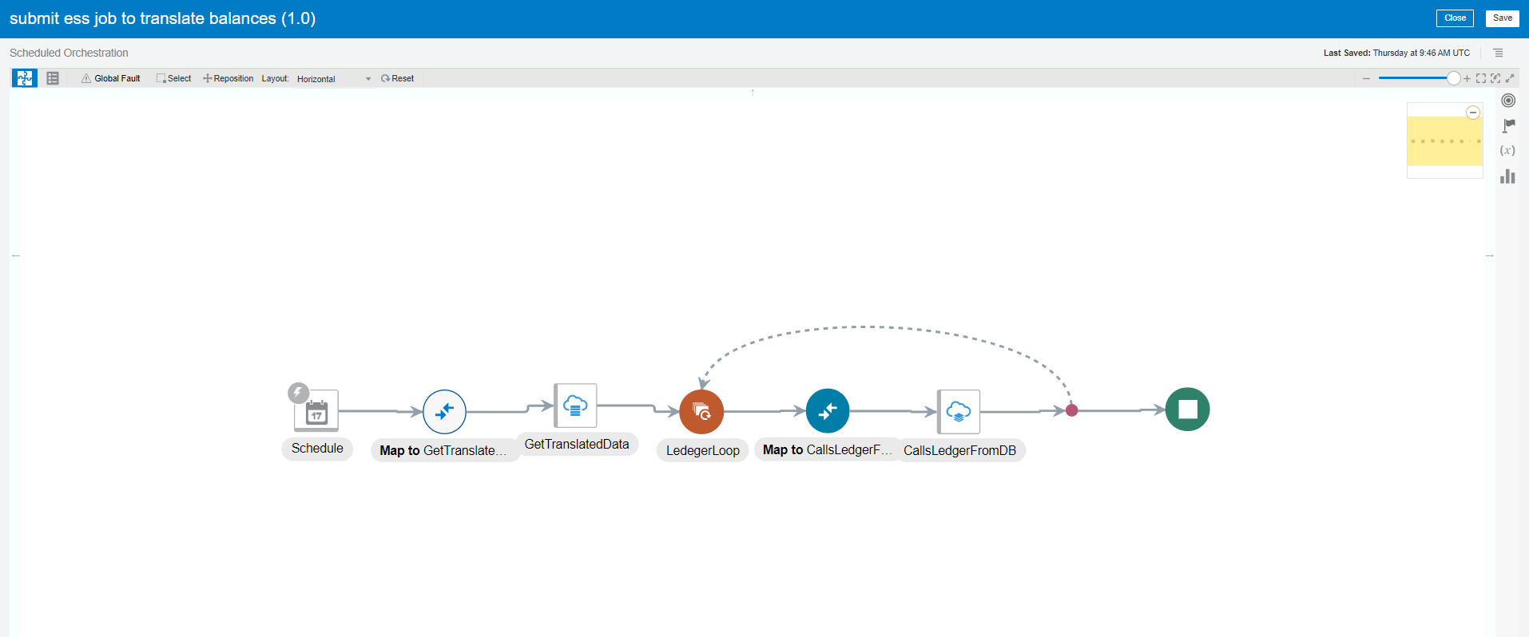
Fig 1: shows the design diagram of the integration submit ess job to translate balances
XXMX_Staging_DB Adapter :
The purpose of the DB adapter is to get the ledger_id values from Database.
Get DB Values DB adapter Configuration
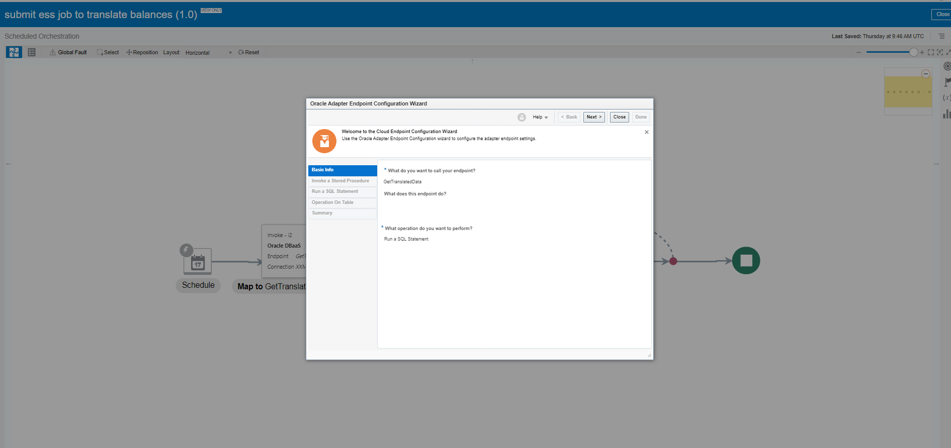
Fig 2: shows the name of the endpoint, purpose of endpoint and operation to be performed on a table

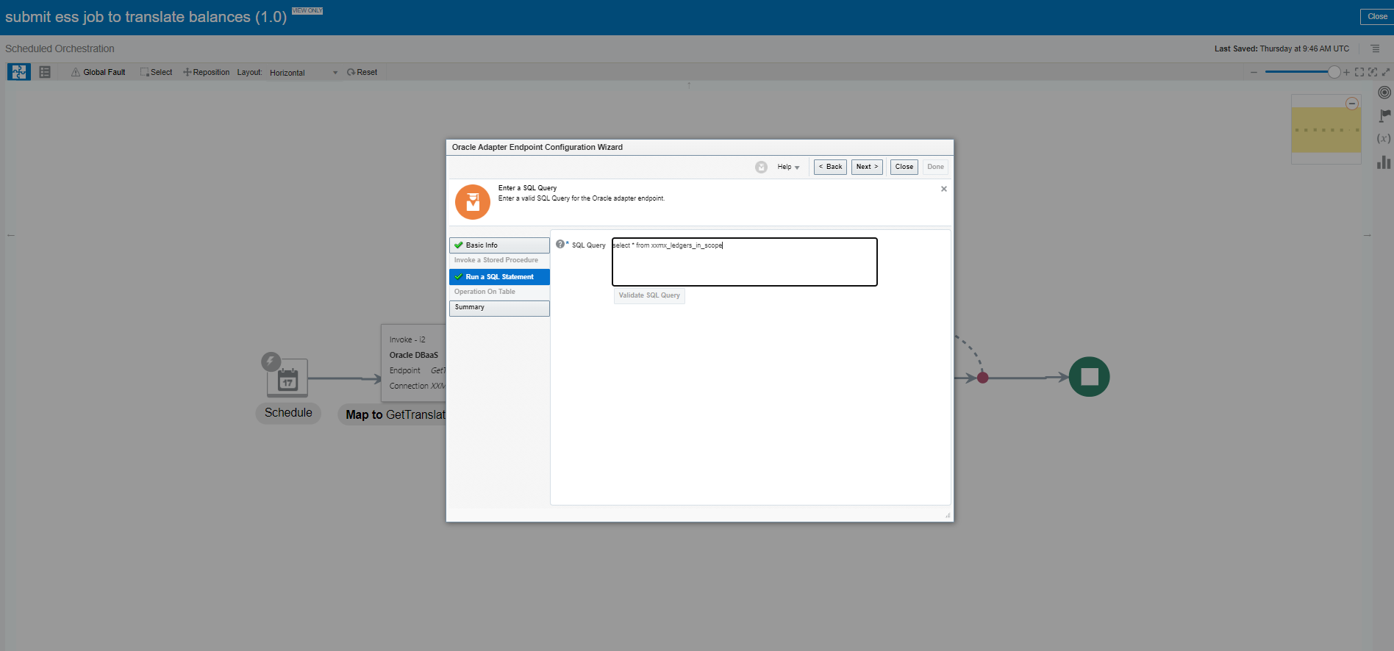
Fig 3: shows the SQL Statement that is performed on the table

SQL Query:
SELECT * FROM XXMX_LEDGERS_IN_SCOPE

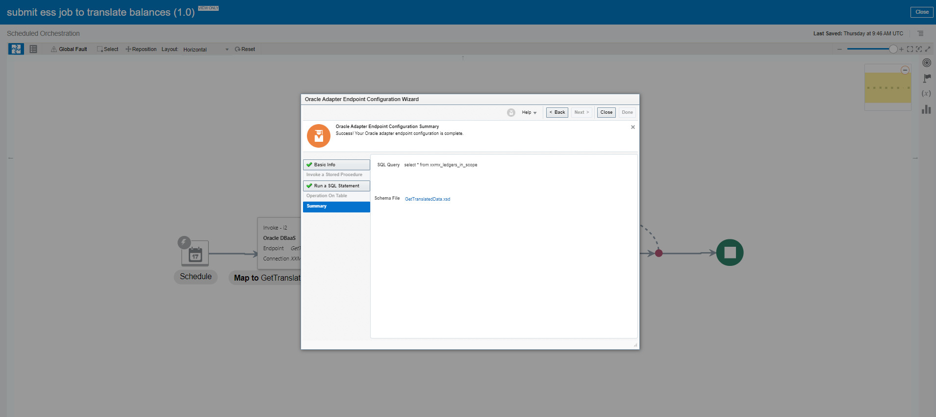
Fig 5: Summary for connection “XXMX_Staging_DB”

Erp Cloud Submit Ess Job Conn:
The purpose of the Erp Cloud Submit Ess Job Conn Adapter is to connect to the Fusion or cloud of the required environment by giving the credentials in the connection created.

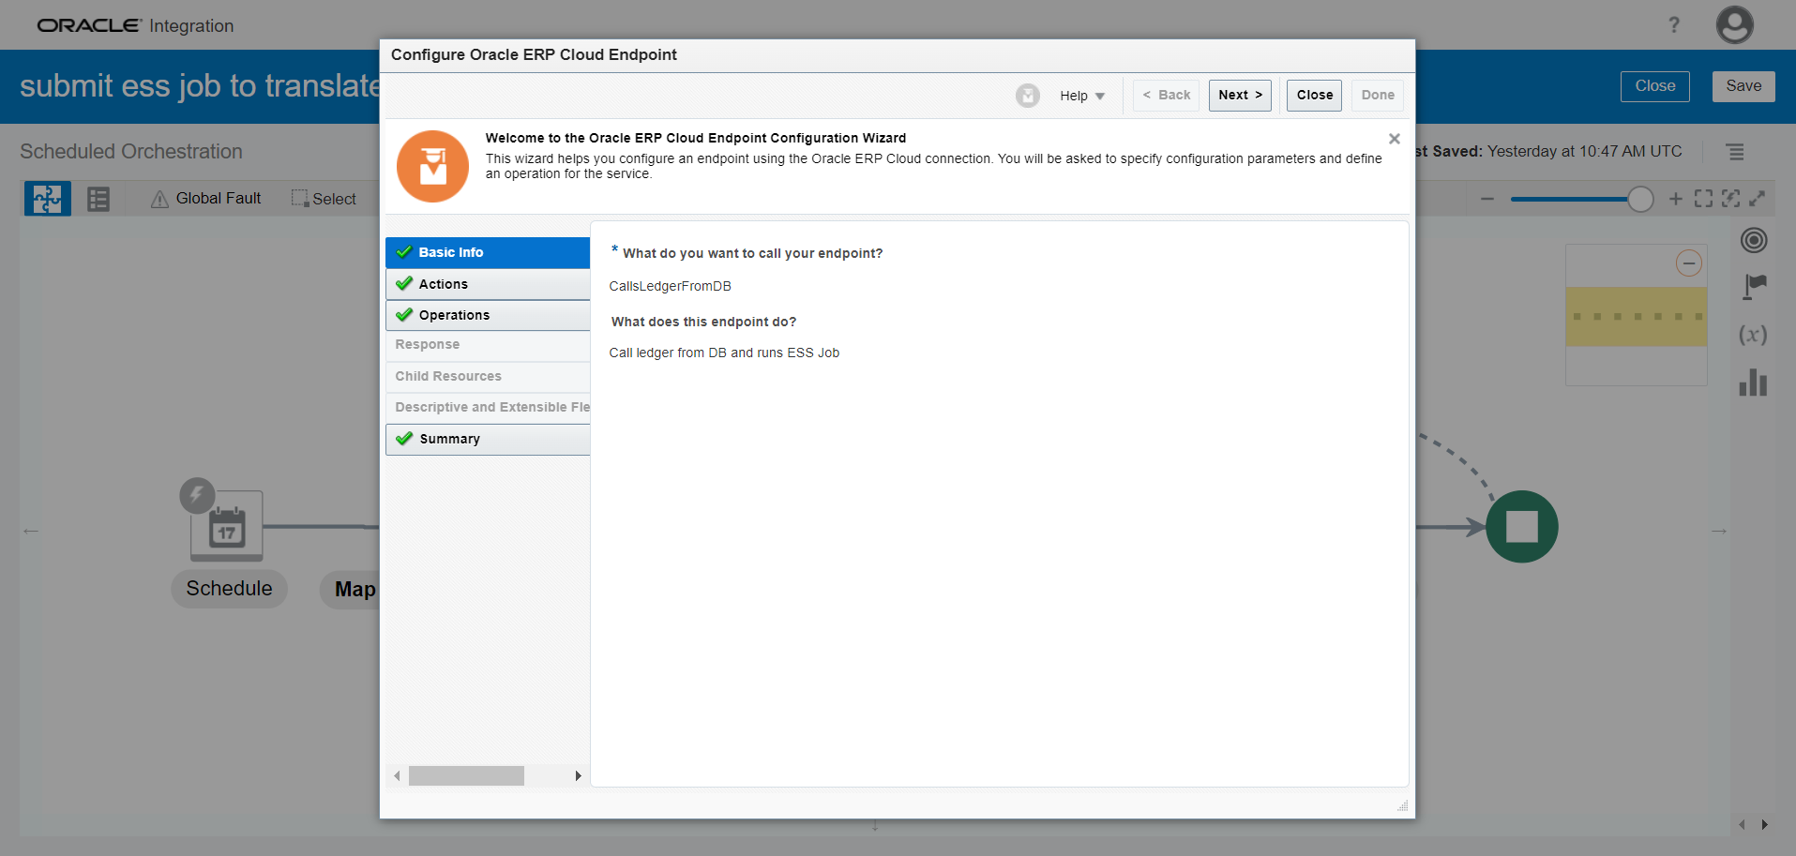
Fig 6: shows the name of the endpoint of Erp Cloud Submit Ess Job Conn

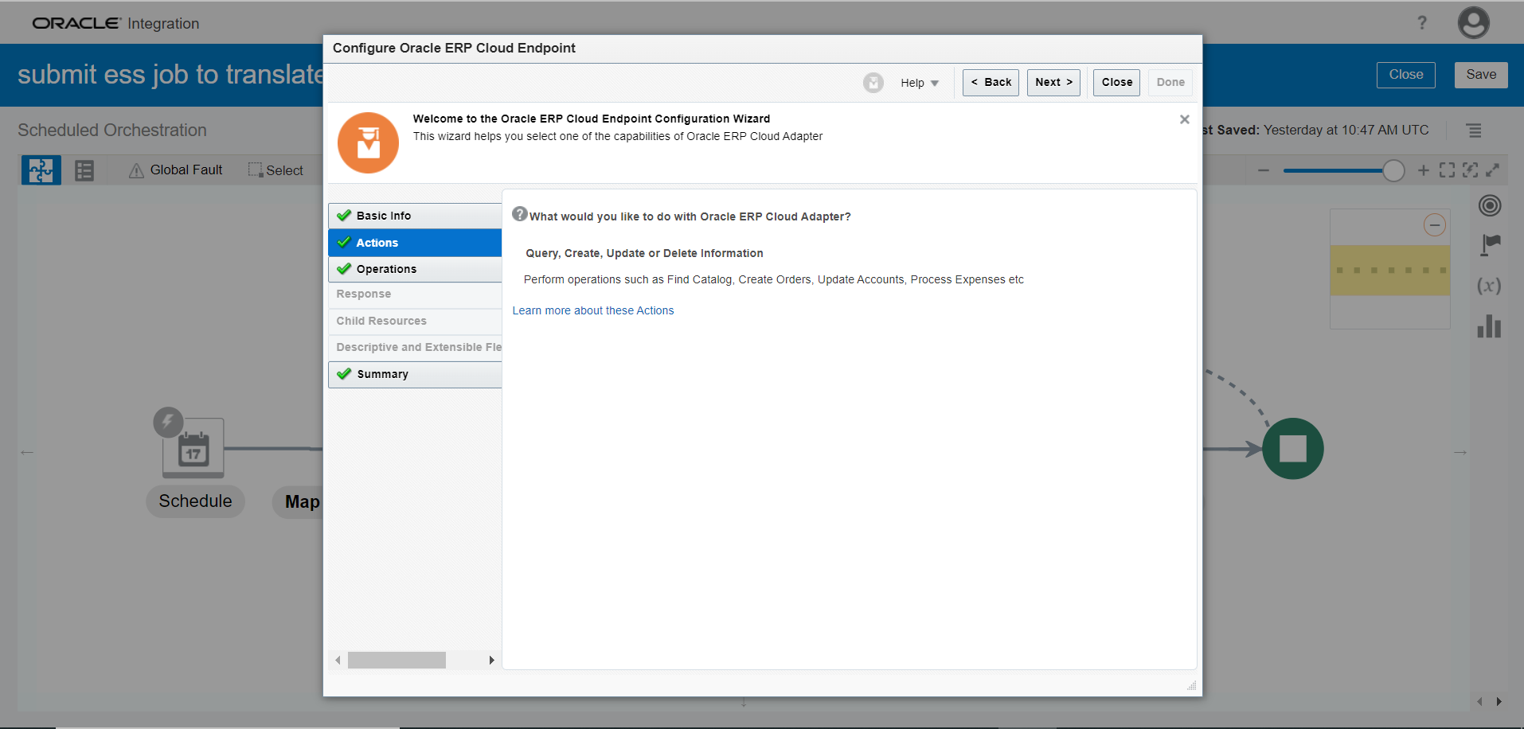
Fig 7: shows the actions to be performed on ERP cloud Adapter

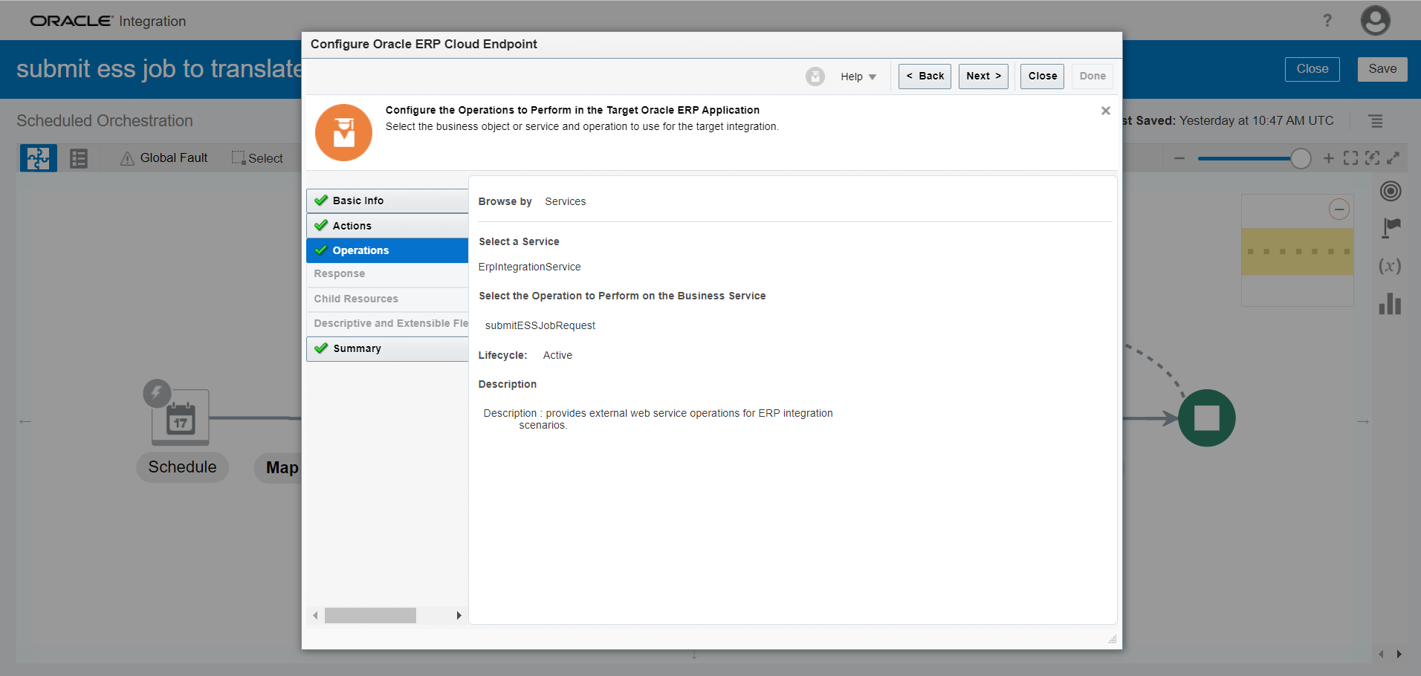
Fig 8 : shows the operations to be performed on ERP cloud Adapter

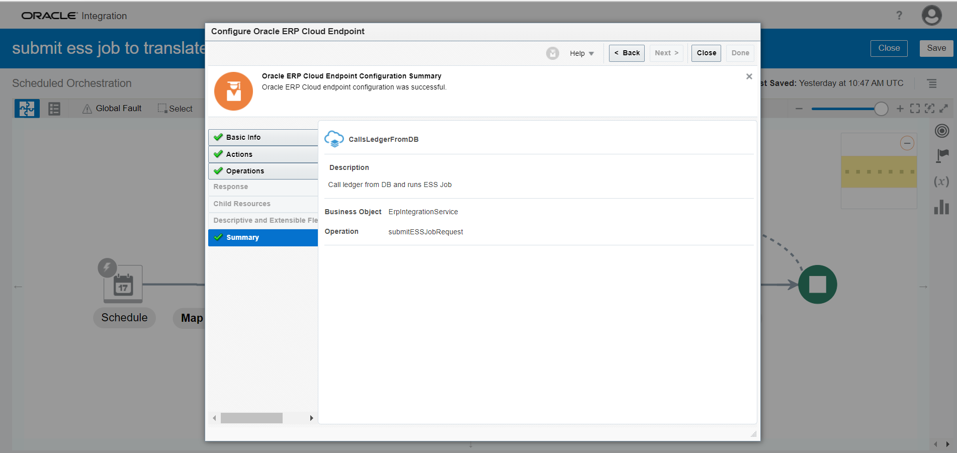
Fig 9: Summary for connection “Erp Cloud Submit Ess Job Conn Adapter”

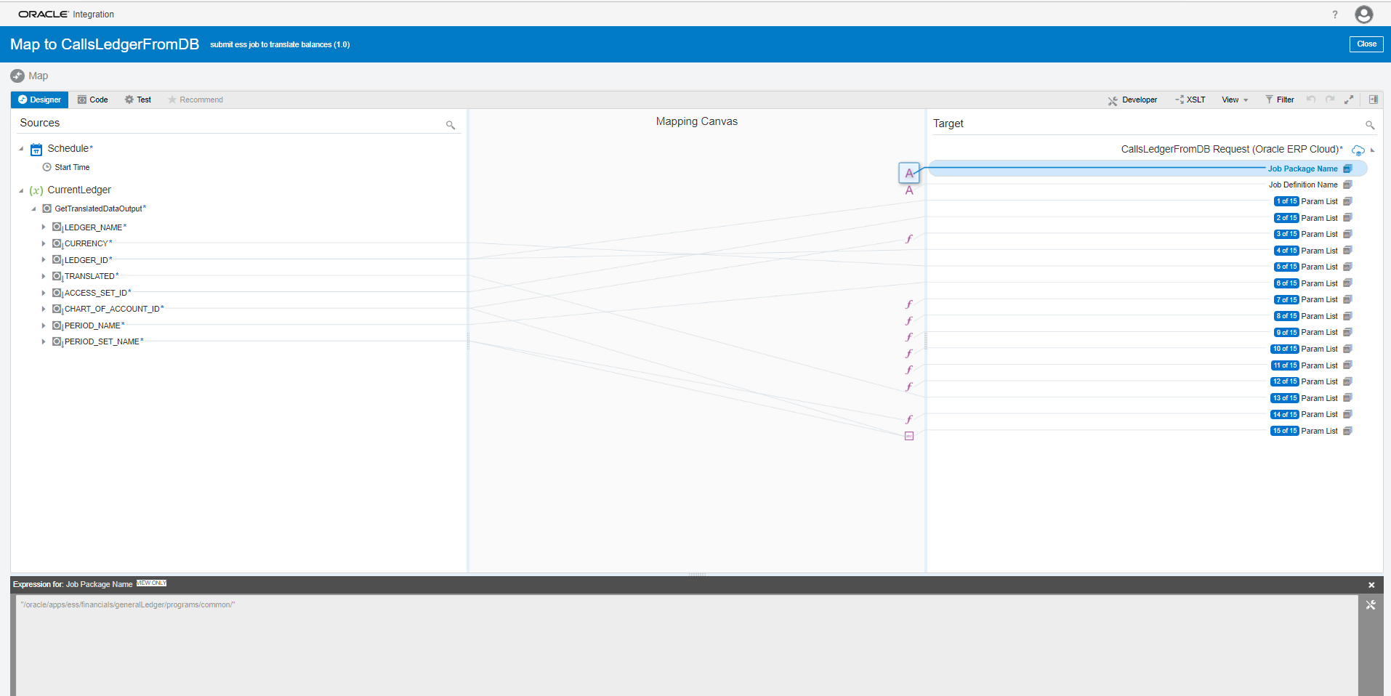
Fig 10: Shows the Job package name "/oracle/apps/ess/financials/generalLedger/programs/common/"

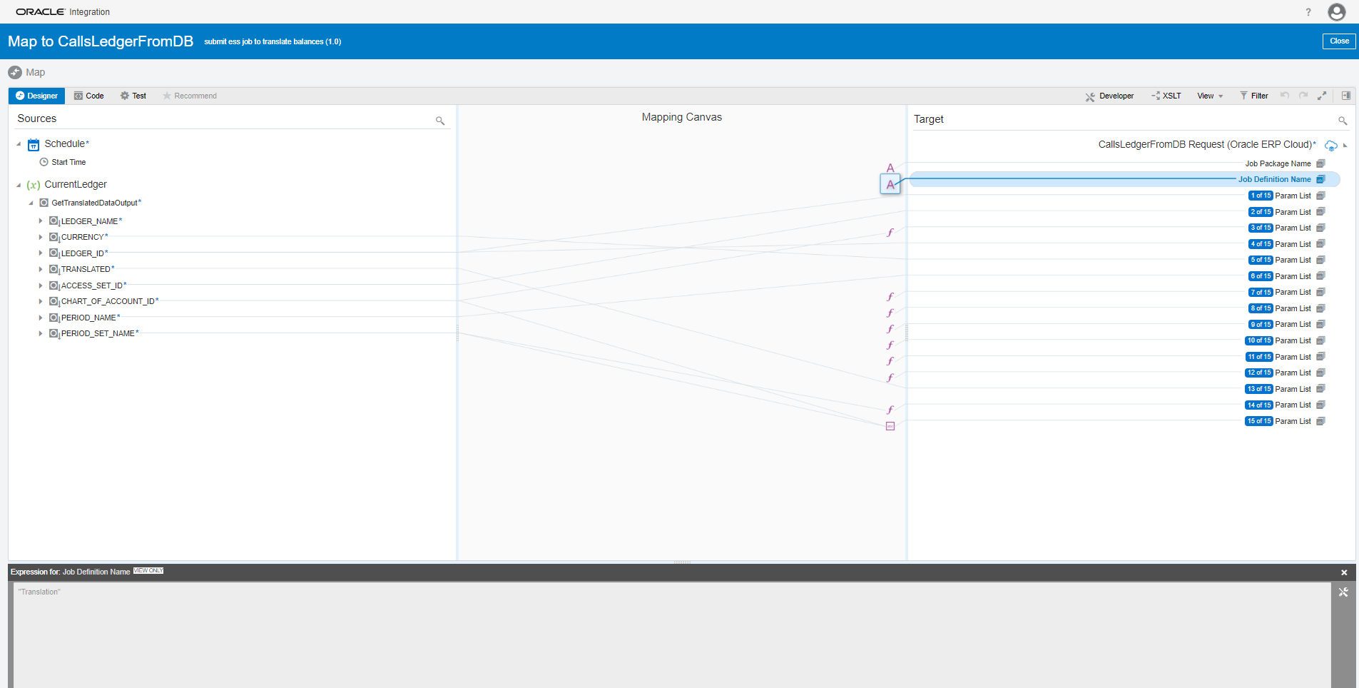
Fig11: Shows the Job Definition Name " Translation"

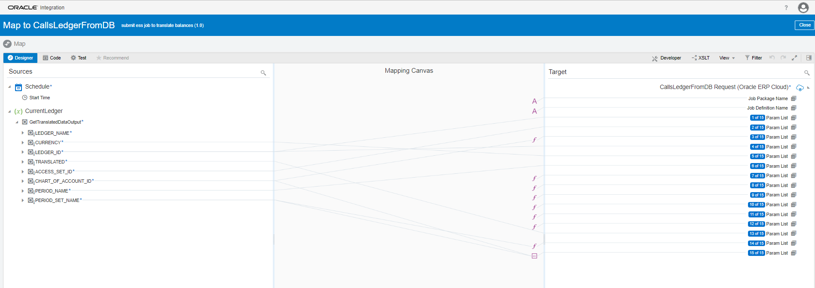
Fig 8: shows the mapping to the parameters

Mappings :
Job Package Name : "/oracle/apps/ess/financials/generalLedger/programs/common/"
Job Definition Name : " Translation"
Parameter 1: mapped to Ledger_Id
Parameter 2: Mapped to Access_Set_Id
Parameter 3: Mapped to Chart_Of_Account_Id and Created a lookup for it to map from ebs to cloud
Parameter 4: mapped to Ledger_Id
Parameter 5: mapped to Currency
Parameter 6: Mapped to Period_Name
Parameter 7:Created a lookup as "A" for balance_type (A=Accepted and Rejected)
Parameter 8: Created a lookup as null
Parameter 9: Created a lookup as null
Parameter 10: Created a lookup as null
Parameter 11: Created a lookup as null
Parameter 12: Created a lookup as null
Parameter 13: Mapped to Translated "Y"
Parameter 14: mapped to Period_Set_Name and Created a lookup for it to map from ebs to cloud
Parameter 15: Concatenated the chart_of_account_id to period_set_name by using certain lookup functions and concat functions (eg: 3001X 300000004109415)

Summary:
- Populate the table xxmx_ledgers_in_scope table with the code:
{
insert into xxmx_ledgers_in_scope
SELECT DISTINCT
B.LEDGER_NAME--ARGUMENT1 & ARGUMENT4
,A.TARGET_CURRENCY_CODE--ARGUMENT5
,B.LEDGER_ID
,'Y' AS TRANSLATED--ARGUMENT13
,B.ACCESS_SET_ID--ARGUMENT2
,D.CHART_OF_ACCOUNTS_ID--ARGUMENT3
,A.PERIOD_NAME--ARGUMENT6
,D.PERIOD_SET_NAME --ARGUMENT14
FROM XXMX_GL_HISTORICALRATES_XFM A,
XXMX_DM_FUSION_DAS B,
XXMX_SIMPLE_TRANSFORMS C,
GL_ACCESS_SETS@XXMX_EXTRACT D
WHERE 1=1
AND A.LEDGER_NAME=B.LEDGER_NAME
AND C.FUSION_VALUE=A.LEDGER_NAME
AND C.SOURCE_VALUE=D.NAME
}
- Run the data model
My Folders-> Amit->translate balances chart_of_account_id and get the cloud chart_of_account_id and compare it in the lookup(Name:translate_balances_lookup), check if the values are matching, if they are not matching change the chart_of_account_id to in the domain_name_3 column to the data model output.
- Run the data model
My Folders-> Amit->translate balances calendar_id and get the cloud calendar_id and compare it in the lookup(Name:translate_balances_lookup), check if the values are matching, if they are not matching change the calendar_id(change the calendar_d as respected) to in the domain_name_3 column to the data model output.
- The integration fetches all the columns from the table xxmx_ledgers_in_scope and executes the query “select * from xxmx_ledgers_in_scope” .
- This process can be monitored in the integration and monitor sessions in the fusion (required environment).

Conclusion:
Activity | Count
For Each | 1
Invoke | 2
Map | 2
Schedule | 1
Total | 6

